

SOFTWARE DESIGN SPECIFICATION
FINORA - CHAIN ​​STORE MANAGEMENT SYSTEM

– Hanoi, July 2026 –

I. Record of Changes 2
II. Software Design Document 4
1. High Level Design 4
1.1 Software Architecture 4
1.2 Package Diagram 5
1.3 Database Design 6
1.3.1 Employee 8
1.3.2 Role 8
1.3.3 customer 9
1.3.4 customer_point 9
1.3.5 products 10
1.3.6 category 11
1.3.7 unit 11
1.3.8 stock_transfer_detail 12
1.3.9 Branch 12
1.3.10 order 13
1.3.11 order_detail 14
1.3.12 stock_transaction 14
1.3.13 audit_log 15
1.3.14 supplier 15
1.3.15 point_transaction 16
1.3.16 payment 16
1.3.17 warehouse 17
1.3.18 inventory 17
1.3.19 stock_transfer 18
1.3.20 shift 18
1.3.21 cash_transaction 19
1.3.22 supplier_product 19
1.3.23 inventory_check_detail 20
1.3.24 loyalty_point_setting 20
1.3.25 vat_setting 21
1.3.26 inventory_check 21
1. Inventory 22
2. Direct Import 22
3. Inventory Transfer 23
4. Check Inventory 24
5. Inventory History 25
6. User Management 26
7. Create User 27
8. Edit User 28
9. Search/Filter User 29
10. Employee Sales Report 30
11. Change Password 31
12. Redeem consumption points 31
13. Lock / Unlock User 32
14. Edit Customer 33
15. Add Customer 34
16. Customer Management 34
17. Search/Filter Customer 36
18. Customer Detail 37
19. Profile 37

I. Record of Changes

Date | A*  M, D | In charge | Change Description
24/06/2026 | A | ChiHTH | 1.1 Software Architecture
11/07/2026 | A | ThangLV | 1.2 Package Diagram (Code Package)
10/07/2026 | A | PhucNH | 1.2 Package Diagram (ERD)
10/07/2026 | A | ChiHTH | 1.2 Package Diagram (Table Description)
10/07/2026 | A | DungLD | 1.3.1 Employee
10/07/2026 | A | DungLD | 1.3.2 Role
10/07/2026 | A | DungLD | 1.3.3 customer
10/07/2026 | A | DungLD | 1.3.4 customer_point
10/07/2026 | A | HoangND | 1.3.5 products
10/07/2026 | A | HoangND | 1.3.6 category
10/07/2026 | A | HoangND | 1.3.7 unit
10/07/2026 | A | HoangND | 1.3.8 stock_transfer_detail
10/07/2026 | A | PhucNH | 1.3.9 Branch
10/07/2026 | A | PhucNH | 1.3.10 order
10/07/2026 | A | PhucNH | 1.3.11 order_detail
10/07/2026 | A | PhucNH | 1.3.12 stock_transaction
13/07/2026 | A | ChiHTH | 1.3.13 audit_log
13/07/2026 | A | ChiHTH | 1.3.14 voucher
13/07/2026 | A | ChiHTH | 1.3.15 supplier
13/07/2026 | A | ChiHTH | 1.3.16 point_transaction
14/07/2026 | A | ThangLV | 1.3.17 payment
14/07/2026 | A | ThangLV | 1.3.18 warehouse
14/07/2026 | A | ThangLV | 1.3.19 inventory
14/07/2026 | A | ThangLV | 1.3.20 stock_transfer
20/07/2026 | A | PhucNH | 1.3.21 shift
21/07/2026 | A | ChiHTH | 1.3.22 cash_transaction
21/07/2026 | A | ChiHTH | 1.3.23 supplier_product
21/07/2026 | A | DungLD | 1.3.24 inventory_check_detail
21/07/2026 | A | DungLD | 1.3.25 loyalty_point_setting
21/07/2026 | A | PhucNH | 1.3.26 inventory_check
21/07/2026 | M | ChiHTH | 1.3.1 Employee
21/07/2026 | A | PhucNH | 1.3.25 vat_setting
21/07/2026 | A | PhucNH | 1.3.26 inventory_check
22/07/2026 | A | ThangLV | Code Designs
22/07/2026 | A | DungLD | Code Designs
23/07/2026 | M | PhucNH | ERD
*A - Added M - Modified D - Deleted

II. Software Design Document

1. High Level Design

1.1 Software Architecture

a. Architectural Overview
The Finora system is built on a centralized web architecture model based on JSP Servlets. The system is designed to manage unified data for a chain of 5-10 branches, where all generated data is linked to the store identifier (store_id) to ensure data separation and security between branches.

b. Components and Subsystems
The Finora software architecture includes the following main functional modules (organized into code packages):
- Authentication & Authorization: Handles login, logout, and role-based authorization (RBAC).
- Inventory & Product Management: Manages product catalogs, inventory transactions (inflow, outflow, inventory checks), and transfers between branches.
- Point of Sale (POS) & Order Management: Handles order creation at the counter, invoice calculation, and order status management.
- Finance: Records non-sales income/expenses, manages cash book and accounts payable to suppliers.
- Customers & Loyalty Program: Manages customer information and membership points.
- Reporting System: Collects data to generate reports on revenue, profit/loss, and inventory.
- Audit Log: Records all user activity logs for auditing purposes.

c. External Systems
The Finora system interacts with external platforms through an application programming interface:
- VNPay Payment Gateway: Integrated to receive payment confirmations via system callbacks.
- Email Service Provider (Gmail/SMTP): Used to send temporary password emails when users use the "Forgot Password" feature and to create new accounts for employees.
- Supplier System: Communicates through purchase orders.

d. Relationships and Data Flow
- Agents: Owners, Store Managers, and Employees interact with the system through a web interface to execute defined Use Cases.
- Communication between Modules: The Payment Management module receives data from Order Management to process payments; upon successful completion, the data is pushed to the Financial Transactions module to update the cash register and to the Inventory Transactions module to deduct inventory.
- Data Constraints: All modules must adhere to the general business rule that data must be linked to the store_id (except for the Owner role, which has the right to view the entire chain).

1.2 Package Diagram

Code package

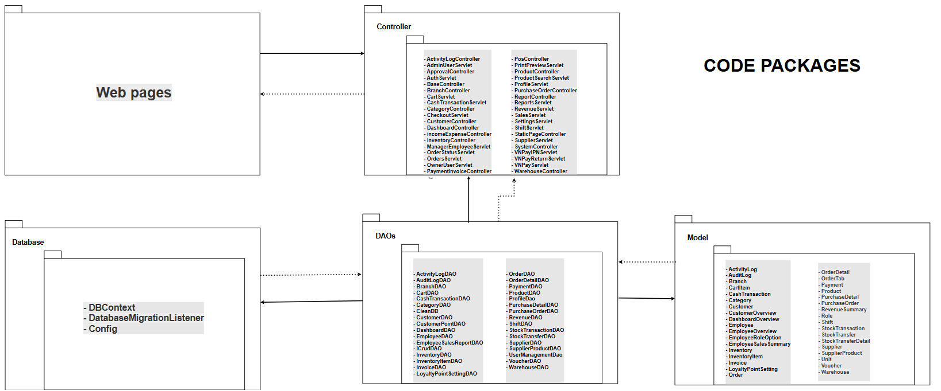

Package descriptions
No | Package | Description
01 | views | Contains user interface (UI) components displayed using JSP, HTML, and CSS pages for a chain store management system.
02 | controllers | Responsible for managing interactions between users, data, and business logic. Includes modular packages such as authentication, branch_management, product_management, order_management, supplier_management, customer_management, and category_management.
03 | DAOs | The Data Access Object class is used to handle data access to the database. It provides basic CRUD methods such as adding, modifying, deleting, and searching for data.
04 | Models / Entities | It contains Model/Entity classes that represent the tables in the database and uses getter/setter functions to manage the data.
05 | Database | The Database/DBContext layer is used to store, configure connections (JDBC), and retrieve data from SQL Server, making data management easier.

1.3 Database Design

a. Database Schema

Database Schema
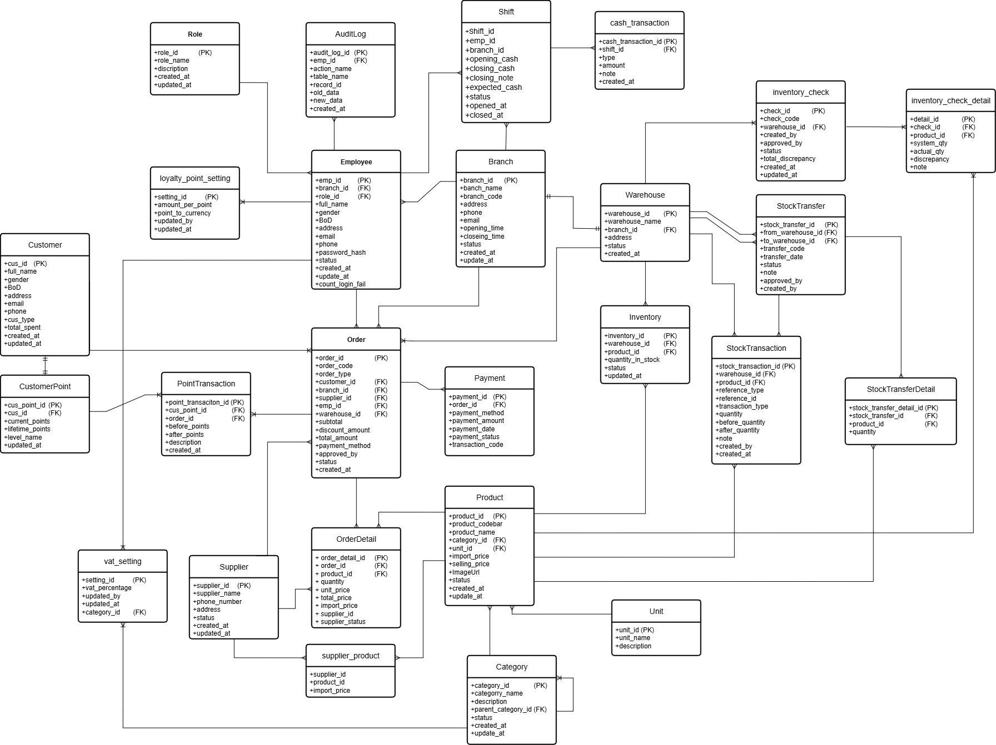

b. Table Description
No | Table | Description
01 | Role | Store all system roles (Admin, Owner, Store Manager, Sales Staff, Warehouse Staff) to facilitate RBAC permission management.
02 | Branch | It stores information about the chain's branches, including managing employees, warehouses, customers, and orders.
03 | Employee | Stores employee information, login credentials (email, passwordHash), and branch location (branch_id).
04 | Product | Stores general product information including name, category, unit of measurement, selling price, and status.
05 | Inventory | Maintain records of the actual inventory levels of each product at each specific warehouse/branch.
06 | Order and OrderDetail | Store information on sales invoices or purchase orders, including details of items, quantities, and total amounts for each transaction..
07 | Customer and CustomerPoint | Store customers' personal information and their current Loyalty points (earned/redeemable).
08 | AuditLog | Record all important user activity on the system (Add, Edit, Delete) for review purposes.

1.3.1 Employee
Description: The Employee table stores employee account and profile information. It is used for authentication, authorization, and employee management. Each employee belongs to one branch and is assigned one role.
No | Field | PK | FK | UN | NN | Description
01 | emp_id | x |  |  | x | Unique identifier of the employee.
02 | branch_id |  | x |  | x | References the branch where the employee works.
03 | role_id |  | x |  | x | References the employee's assigned role.
04 | fullName |  |  |  | x | Full name of the employee.
05 | gender |  |  |  |  | Employee gender.
06 | bod |  |  |  |  | Employee date of birth.
07 | address |  |  |  |  | Employee residential address.
08 | email |  |  | x |  | Employee email address.
09 | phone |  |  | x |  | Employee phone number.
10 | passwordHash |  |  |  |  | Encrypted password used for login.
11 | image_URL |  |  |  |  | URL of the employee profile image.
12 | status |  |  |  |  | Employee account status (ACTIVE/INACTIVE).
13 | created_at |  |  |  |  | Record creation timestamp.
14 | update_at |  |  |  |  | Last update timestamp.
15 | count_login_fail |  |  |  |  | Count the number of failed login attempts.

1.3.2 Role
Description: The Role table stores the roles assigned to employees. It supports role-based access control (RBAC) throughout the system.
No | Field | PK | FK | UN | NN | Description
01 | role_id | x |  |  | x | Unique identifier of the role.
02 | role_name |  |  |  | x | Name of the role.
03 | discription |  |  |  |  | Description of the role.
04 | created_at |  |  |  |  | Record creation timestamp.
05 | update_at |  |  |  |  | Last update timestamp.

1.3.3 customer
Description: The customer table stores customer information used for sales transactions and the loyalty points program.
No | Field | PK | FK | UN | NN | Description
01 | cus_id | x |  |  | x | Unique identifier of the customer.
02 | full_name |  |  |  | x | Customer full name.
03 | gender |  |  |  |  | Customer gender.
04 | bod |  |  |  |  | Customer date of birth.
05 | address |  |  |  |  | Customer address.
06 | email |  |  | x |  | Customer email address.
07 | phone |  |  | x |  | Customer phone number.
08 | total_spent |  |  |  |  | Total amount spent by the customer.
09 | status |  |  |  |  | Customer account status (ACTIVE/INACTIVE).
10 | created_at |  |  |  |  | Record creation timestamp.
11 | updated_at |  |  |  |  | Last update timestamp.

1.3.4 customer_point
Description: The customer_point table stores loyalty point information for each customer. Each customer has only one corresponding loyalty point record.
No | Field | PK | FK | UN | NN | Description
01 | cus_point_id | x |  |  | x | Unique identifier of the customer point record.
02 | cus_id |  | x | x | x | References the corresponding customer. Each customer can have only one point account.
03 | current_points |  |  |  |  | Current redeemable loyalty points.
04 | lifetime_points |  |  |  |  | Total lifetime loyalty points accumulated by the customer.
05 | updated_at |  |  |  |  | Last update timestamp of the loyalty points

1.3.5 products
Description: The Product table stores information about products, including their category, unit of measurement, selling price, and status.

No | Field | PK | FK | UN | NN | Description
01 | product_id | x |  |  | x | The unique identifier of the product.
02 | product_codebar |  |  | x | x | Product barcode
03 | product_name |  |  |  | x | Product name
04 | category_id |  | x |  | x | The product category code belongs to
05 | unit_id |  | x |  | x | Product unit code
06 | selling_price |  |  |  | x | The selling price of the product
07 | created_at |  |  |  | x | Record creation time
08 | update_at |  |  |  |  | Record update time
09 | Status |  |  |  | x | Status of product

1.3.6 category
Description: The Category table stores information about product categories, including hierarchical relationships and category status.

No | Field | PK | FK | UN | NN | Description
01 | category_id | x |  |  | x | The unique identifier of the category.
02 | category_name |  |  |  | x | Name of the category
03 | description |  |  |  |  | Detailed description of the category
04 | parent_category_id |  |  |  |  | Parent category code (for creating hierarchy)
05 | status |  |  |  | x | Category status
06 | created_at |  |  |  | x | Record creation time
07 | update_at |  |  |  |  | Record update time

1.3.7 unit
Description: The Unit table stores information about product units of measurement used throughout the system.

No | Field | PK | FK | UN | NN | Description
01 | unit_id | x |  |  | x | Unique identifier of the unit
02 | unit_name |  |  | x | x | Unit of measurement (e.g., piece, kg, box)
03 | description |  |  |  |  | Detailed description of the unit

1.3.8 stock_transfer_detail
Description: The StockTransferDetail table stores the details of products included in each stock transfer, including the transferred product and quantity.

No | Field | PK | FK | UN | NN | Description
01 | stock_transfer_detail_id | x |  |  | x | Warehouse Transfer Identification Code
02 | stock_transfer_id |  | x |  | x | Warehouse transfer slip code
03 | product_id |  | x |  | x | Product code transferred
04 | quantity |  |  |  | x | Quantity of products in the order

1.3.9 Branch

Description: Stores information about each branch in the system, including its identification, location, contact details, operating hours, status, and image. This table is used to manage branch information across the retail chain.

No | Field | PK | FK | UN | NN | Description
01 | branch_id | x |  |  |  | Unique identifier for the branch.
02 | branch_name |  |  |  | x | Name of the branch.
03 | branch_code |  |  | x | x | Unique code representing the branch.
04 | address |  |  |  |  | Physical address of the branch.
05 | district |  |  |  |  | District where the branch is located.
06 | city |  |  |  |  | City where the branch is located.
07 | phone |  |  | x |  | Contact phone number of the branch.
08 | email |  |  | x |  | Contact email address of the branch.
09 | opening_time |  |  |  |  | Opening time of the branch.
10 | closing_time |  |  |  |  | Closing time of the branch.
11 | status |  |  |  |  | Current operating status of the branch.
12 | image_URL |  |  |  |  | URL path to the branch's image.
13 | created_at |  |  |  |  | Timestamp when the record was created.
14 | update_at |  |  |  |  | Timestamp when the record was last updated.

1.3.10 order

Description: Stores information about customer and supplier orders, including order details, related entities, payment information, and order status. This table serves as the main record for all business transactions.

No | Field | PK | FK | UN | NN | Description
01 | order_id | x |  |  | x | Unique identifier for the order.
02 | order_code |  |  | x |  | Unique code representing the order.
03 | order_type |  |  |  |  | Type of the order.
04 | customer_id |  | x |  |  | Reference to the customer who placed the order.
05 | branch_id |  | x |  |  | Reference to the branch where the order was placed.
06 | supplier_id |  | x |  |  | Reference to the supplier related to the order.
07 | emp_id |  | x |  |  | Reference to the employee who processed the order.
08 | warehouse_id |  | x |  |  | Reference to the warehouse involved in the order.
09 | subtotal |  |  |  |  | Subtotal of the order.
10 | discount_amount |  |  |  |  | Discount amount applied to the order.
11 | total_amount |  |  |  |  | Total amount of the order.
12 | payment_method |  |  |  |  | Payment method used for the order.
13 | status |  |  |  |  | Current status of the order.
15 | created_at |  |  |  |  | Timestamp when the order was created.

1.3.11 order_detail

Description: Stores the detailed line items of each order, including the products, quantities, prices, and total amount for each item. Each record represents one product within an order. Stores the detailed line items of each order, including the products, quantities, prices, and total amount for each item.
No | Field | PK | FK | UN | NN | Description
01 | order_detail_id | x |  |  |  | Unique identifier for the order detail.
02 | order_id |  | x |  | x | Reference to the order.
03 | product_id |  | x |  | x | Reference to the product.
04 | quantity |  |  |  |  | Quantity of the product in the order.
05 | unit_price |  |  |  |  | Unit price of the product.
06 | import_price |  |  |  |  | Import price of the product.
07 | total_price |  |  |  |  | Total price for this order detail.

1.3.12 stock_transaction

Description: Stores the history of all inventory movements, including stock in, stock out, transfers, and adjustments. Each transaction records the source document, quantity changes, and inventory levels before and after the transaction for inventory tracking and auditing purposes.

No | Field | PK | FK | UN | NN | Description
01 | stock_transaction_id | x |  |  |  | Unique identifier for the stock transaction record.
02 | warehouse_id |  | x |  | x | Reference to the warehouse where the stock transaction occurred.
03 | product_id |  | x |  | x | Reference to the product affected by the stock transaction.
04 | reference_type |  |  |  |  | Indicates the type of source document that generated the stock transaction (e.g., Sale Order, Purchase Order, Stock Transfer).
05 | reference_id |  |  |  |  | Stores the identifier of the source document specified by the reference_type.
06 | transaction_type |  |  |  |  | Specifies the type of stock movement, such as stock in, stock out, transfer in, transfer out, or adjustment.
07 | quantity |  |  |  |  | Quantity of the product involved in the stock transaction.
08 | before_quantity |  |  |  |  | Quantity of the product in stock before the transaction was processed.
09 | after_quantity |  |  |  |  | Quantity of the product in stock after the transaction was processed.
10 | note |  |  |  |  | Additional remarks or comments related to the stock transaction.
11 | created_by |  |  |  |  | Identifier of the employee who created the stock transaction record.
12 | created_at |  |  |  |  | Date and time when the stock transaction record was created.

1.3.13 audit_log
Description: The system's data change history log is used for auditing purposes and to monitor user/employee behavior.
No | Field | PK | FK | UN | NN | Description
01 | audit_log_id | x |  |  | x | The primary key automatically increments the identifier for each log entry.
02 | emp_id |  | x |  | x | The foreign key links to the employee table, identifying the person who performed the action.
03 | action_name |  |  |  | x | Type of operation (Add, Edit, Delete).
04 | table_name |  |  |  | x | The name of the table where the data has changed.
05 | record_id |  |  |  | x | The ID of the specific record affected in that table.
06 | old_data |  |  |  |  | Old data before editing
07 | new_data |  |  |  |  | New data after editing
08 | created_at |  |  |  | x | The time the system recorded this log.

1.3.14 supplier
Description: This table stores information about suppliers (product suppliers) in the Finora system.
No | Field | PK | FK | UN | NN | Description
01 | supplier_id | x |  |  | x | A unique identifier for each supplier.
02 | supplier_name |  |  |  | x | Name of the supplier/partner.
03 | phone_number |  |  | x | x | Contact phone number (unique to avoid duplication with other partners).
04 | address |  |  |  |  | The address of the supplier's office or headquarters (can be NULL).
05 | status |  |  |  | x | Status of cooperation
06 | created_at |  |  |  | x | The time the system recorded this supplier.
07 | updated_at |  |  |  | x | The time the supplier information was last updated.

1.3.15 point_transaction
Description: This table records the history of reward point changes (points added/redeemed) for customers when performing activities or making order transactions within the system.
No | Field | PK | FK | UN | NN | Description
01 | point_transaction_id | x |  |  | x | A unique identifier for each point transaction.
02 | cus_point_id |  | x |  | x | Foreign key linked to the customer's scorecard.
03 | order_id |  | x |  |  | Foreign key linking to the orders table.
04 | before_points |  |  |  | x | The customer's points balance before this transaction.
05 | after_points |  |  |  | x | The customer's points balance after this transaction.
06 | description |  |  |  |  | Content/Reason for score fluctuations
07 | created_at |  |  |  | x | The time when the point transaction occurs.

1.3.16 payment
Description: The Payment table logs all financial transactions (income and expense) related to orders, suppliers, or other operational activities.
No | Field | PK | FK | UN | NN | Description
01 | payment_id | x |  |  | x | Unique identifier of the payment.
02 | order_id |  | x |  |  | Reference to the order.
03 | payment_method |  |  |  |  | Payment method (Cash, Transfer, etc.).
04 | payment_amount |  |  |  |  | The amount of the payment.
05 | payment_date |  |  |  |  | Timestamp when the payment was made.
06 | payment_status |  |  |  |  | Status of the payment (e.g., PENDING, COMPLETED).
07 | transaction_code |  |  |  |  | Bank transaction code if applicable.
08 | payment_type |  |  |  | x | Type of payment (INCOME, EXPENSE).
09 | description |  |  |  |  | Additional description or note.
10 | employee_id |  | x |  |  | Reference to the employee processing payment.
11 | branch_id |  | x |  |  | Reference to the branch.

1.3.17 warehouse
Description: The Warehouse table stores warehouse information linked to specific branches.
No | Field | PK | FK | UN | NN | Description
01 | warehouse_id | x |  |  | x | Unique identifier of the warehouse.
02 | warehouse_name |  |  |  | x | Name of the warehouse.
03 | branch_id |  | x | x | x | Reference to the branch it belongs to.
04 | address |  |  |  |  | Address of the warehouse.
05 | status |  |  |  |  | Current status of the warehouse (default 'active').
06 | created_at |  |  |  |  | Record creation timestamp.

1.3.18 inventory
Description: The Inventory table tracks the real-time stock quantity of each product within a specific warehouse.
No | Field | PK | FK | UN | NN | Description
01 | inventory_id | x |  |  | x | Unique identifier of the inventory record.
02 | warehouse_id |  | x | x | x | Reference to the warehouse (Composite Unique).
03 | product_id |  | x | x | x | Reference to the product (Composite Unique).
04 | quantity_in_stock |  |  |  |  | Current quantity available in stock.
05 | updated_at |  |  |  |  | Last time the stock was updated.

1.3.19 stock_transfer
Description: The StockTransfer table records stock transfer transactions between warehouses, including transfer details, status, and responsible employees.
No | Field | PK | FK | UN | NN | Description
01 | stock_transfer_id | x |  | x | x | Stock transfer slip code (Primary key, auto-increment)
02 | from_warehouse_id |  | x |  | x | Source warehouse code (Foreign key referencing the warehouse table)
03 | to_warehouse_id |  | x |  | x | Destination warehouse code (Foreign key referencing the warehouse table)
04 | transfer_code |  |  | x | x | Stock transfer slip identifier (e.g., TRF-YYYYMMDD-XXXXX)
05 | transfer_date |  |  |  | x | Voucher/Stock transfer creation time (Default: GETDATE())
06 | status |  |  |  | x | Ticket status (PENDING, IN_TRANSIT, COMPLETED, CANCELLED)
07 | note |  |  |  |  | Note the reason for the warehouse transfer or any additional information.
08 | created_by |  | x |  |  | Employee ID of the person who created the ticket (Foreign key referencing the employee table)
09 | approved_by |  | x |  |  | Employee ID/Manager approving the request (Foreign key referencing the employee table)

1.3.20 shift
Description: The Shift table stores cashier shift information, including the assigned employee, branch, opening and closing cash amounts, expected cash balance, shift status, and opening/closing timestamps for cash management and reconciliation.
No | Field | PK | FK | UN | NN | Description
01 | shift_id | x |  |  | x | Unique identifier of the shift.
02 | emp_id |  | x |  | x | References the employee responsible for the shift.
03 | branch_id |  | x |  | x | References the branch where the shift takes place.
04 | opening_cash |  |  |  |  | Cash amount available at the beginning of the shift.
05 | closing_cash |  |  |  |  | Actual cash counted at the end of the shift.
06 | expected_cash |  |  |  |  | System-calculated expected cash amount at shift closing
07 | status |  |  |  |  | Current status of the shift (e.g., OPEN, CLOSED).
08 | opened_at |  |  |  |  | Date and time when the shift was opened.
09 | closed_at |  |  |  |  | Date and time when the shift was closed.

1.3.21 cash_transaction
Description: A log for managing cash inflow and outflow transactions during a shift (adding funds to or withdrawing funds from the cash drawer).
No | Field | PK | FK | UN | NN | Description
01 | cash_transaction_id | x |  | x | x | Cash transaction code (Primary key, auto-increment)
02 | shift_id |  | x |  | x | Shift code (Foreign key referencing the shift table)
03 | type |  | x |  | x | Transaction type (WITHDRAW: Withdrawal, DEPOSIT: Deposit)
04 | amount |  |  |  | x | Số tiền giao dịch (DECIMAL(18,2))
05 | note |  |  |  |  | Note/reason for the transaction
06 | created_at |  |  |  | x | Transaction creation time (Default: GETDATE())

1.3.22 supplier_product
Description: An intermediate table storing the relationship between Suppliers and Products.
No | Field | PK | FK | UN | NN | Description
01 | supplier_id | x | x |  | x | Foreign key referencing the Supplier table
02 | product_id | x | x |  | x | Foreign key referencing the Product table
03 | import_price |  |  |  | x | Import price of the product from this supplier

1.3.23 inventory_check_detail
Description: Stores the detailed results of each product counted during an inventory check, including the system quantity, actual counted quantity, discrepancy, and notes.
No | Field | PK | FK | UN | NN | Description
01 | detail_id | x |  | x | x | Inventory check detail code (Primary key, auto-increment)
02 | check_id |  | x |  | x | Inventory check code (Foreign key referencing the inventory_check table)
03 | product_id |  | x |  | x | Product code (Foreign key referencing the product table)
04 | system_qty |  |  |  | x | Quantity recorded in the system before stock check
05 | actual_qty |  |  |  | x | Actual quantity counted during the inventory check
06 | discrepancy |  |  |  | x | Difference between actual quantity and system quantity (Actual − System)
07 | note |  |  |  |  | Additional notes or explanation for the discrepancy

1.3.24 loyalty_point_setting
Description: Stores the loyalty point conversion settings used by the system, including the amount required to earn one point and the monetary value of one point when redeeming.
No | Field | PK | FK | UN | NN | Description
01 | setting_id | x |  |  | x | Loyalty point setting code (Primary key, auto-increment)
02 | amount_per_point |  |  |  | x | Amount of money required to earn one loyalty point (DECIMAL(18,2))
03 | point_to_currency |  |  |  |  | Monetary value of one loyalty point when redeemed (DECIMAL(18,2))
04 | updated_by |  | x |  |  | User who last updated the setting (Foreign key referencing the employee/user table)
05 | updated_at |  |  |  |  | Date and time when the setting was last updated

1.3.25 vat_setting
Description: The VatSetting table stores the current Value Added Tax (VAT) rate applied by the system. It also records the employee who last updated the VAT percentage and the timestamp of the latest update. This table ensures that sales and purchase transactions use a consistent and centrally managed VAT rate.
No | Field | PK | FK | UN | NN | Description
01 | setting_id | x |  |  | x | Unique identifier of the VAT setting.
02 | vat_percentage |  |  |  | x | The VAT rate applied by the system, expressed as a percentage (e.g., 8.00, 10.00).
03 | updated_by |  | x |  |  | References the employee who last updated the VAT setting.
04 | updated_at |  |  |  |  | Date and time when the VAT setting was last updated.

1.3.26 inventory_check
Description: The InventoryCheck table stores information about inventory stock check sessions conducted in a warehouse. It records the warehouse being checked, the employee who created the inventory check, the approver (if applicable), the check status, the total inventory discrepancy, and timestamps for tracking the inventory verification process.

No | Field | PK | FK | UN | NN | Description
01 | check_id | x |  |  | x | Unique identifier of the inventory check.
02 | check_code |  |  |  | x | Unique code assigned to the inventory check.
03 | warehouse_id |  | x |  | x | References the warehouse where the inventory check is performed.
04 | created_by |  | x |  | x | References the employee who created the inventory check.
05 | approved_by |  | x |  |  | References the employee who approved the inventory check.
06 | status |  |  |  | x | Current status of the inventory check (e.g., PENDING, APPROVED, COMPLETED, CANCELLED).
07 | total_discrepancy |  |  |  |  | Total quantity difference between the system inventory and the physical inventory.
08 | created_at |  |  |  |  | Date and time when the inventory check was created.
09 | updated_at |  |  |  |  | Date and time when the inventory check was last updated.

III. Code Designs

1. Inventory
- Class Diagram
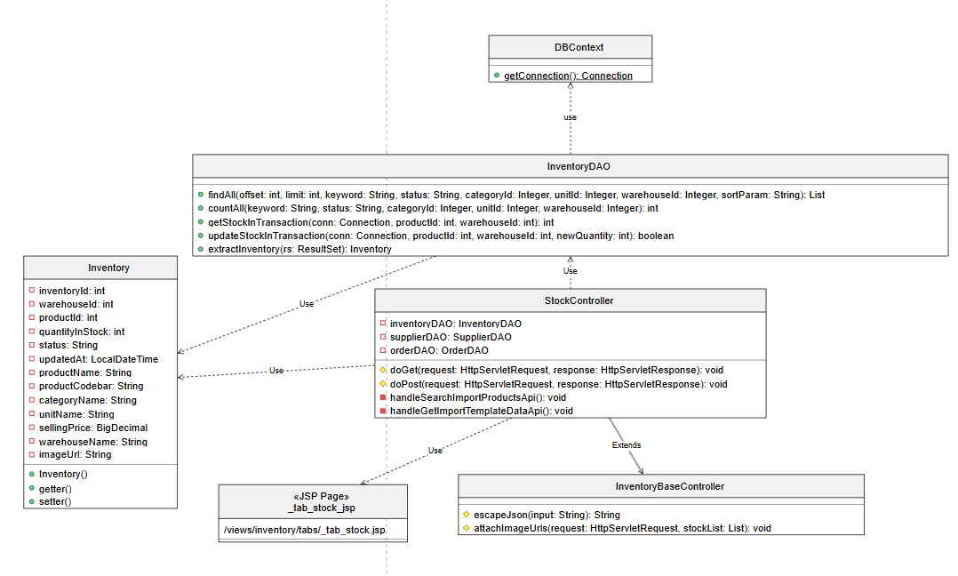

2. Direct Import
- Class Diagram
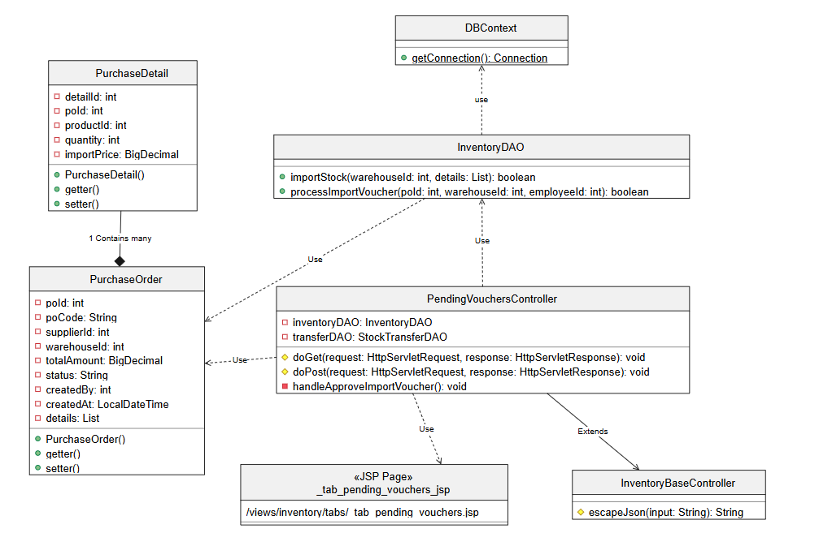

3. Inventory Transfer
- Class Diagram
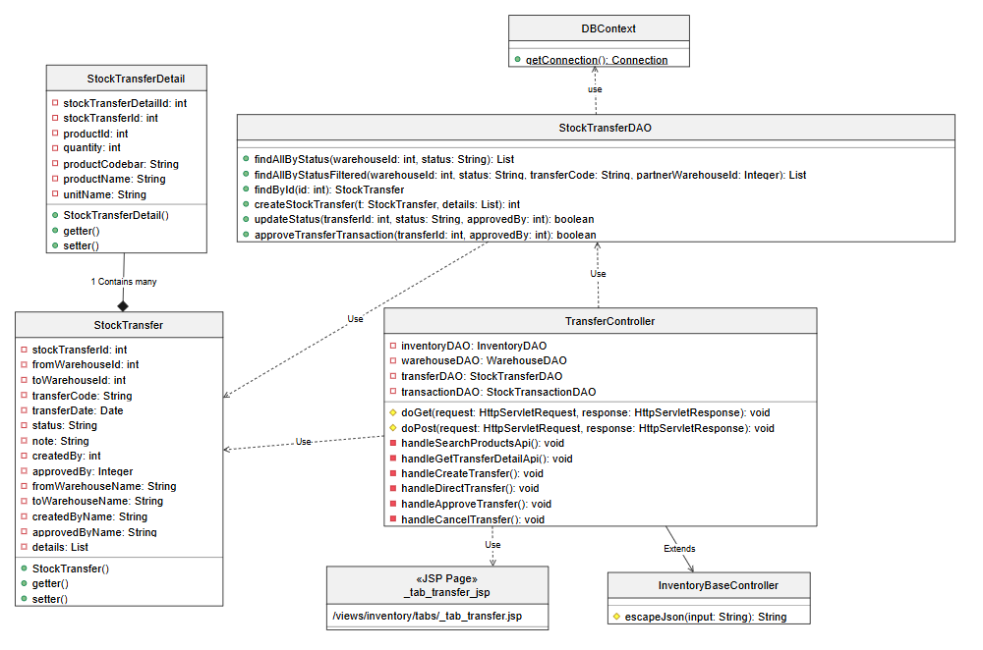

4. Check Inventory
- Class Diagram
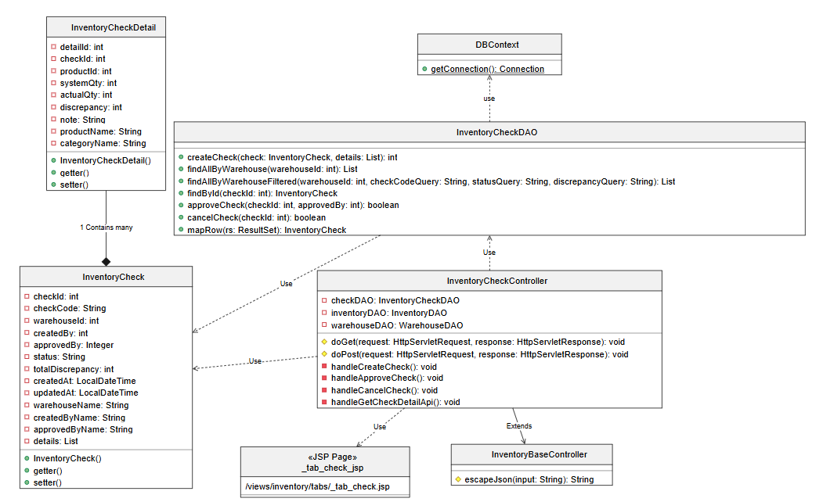

5. Inventory History
- Class Diagram
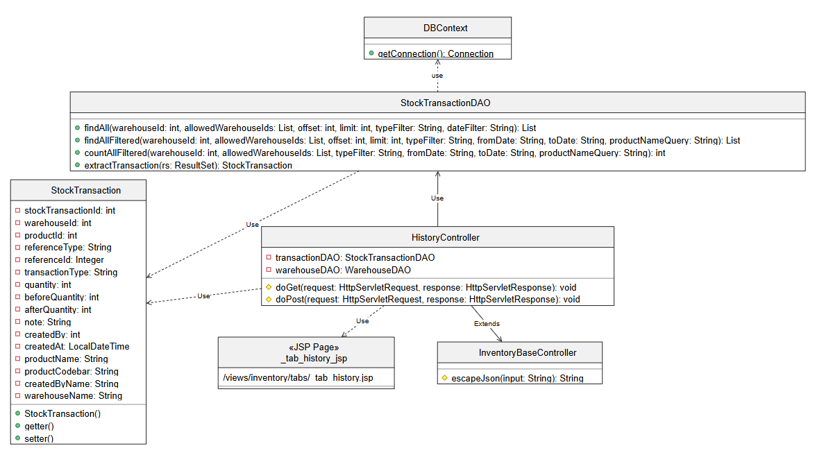

6. User List
- Class Diagram
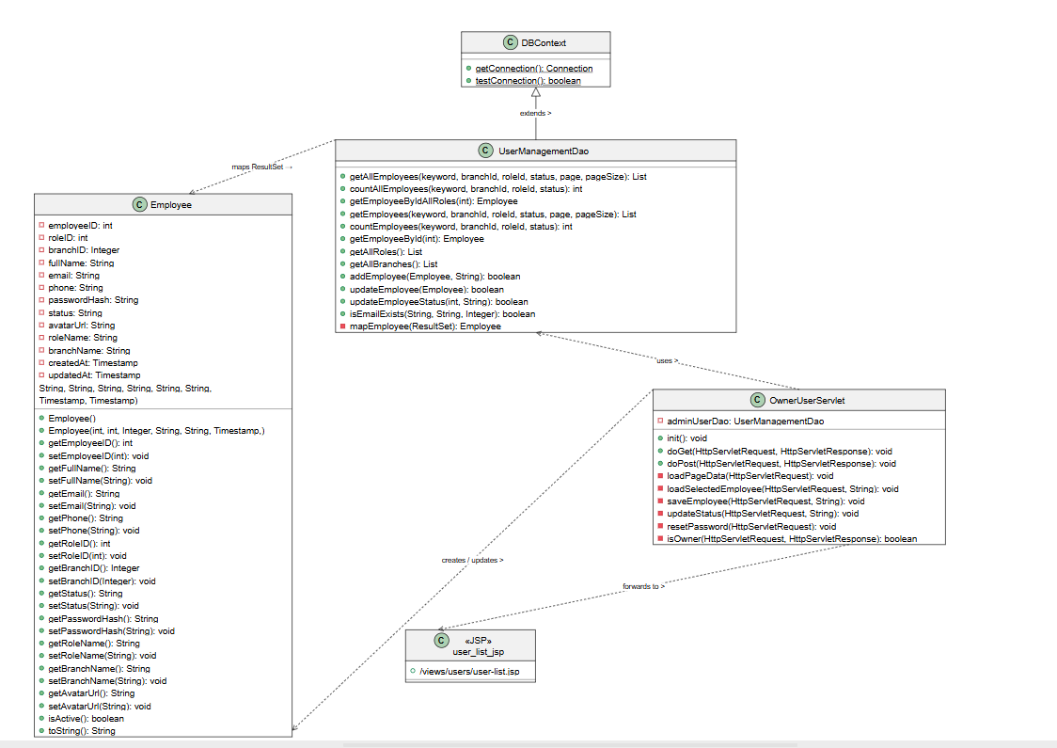

7. Create User
- Class Diagram
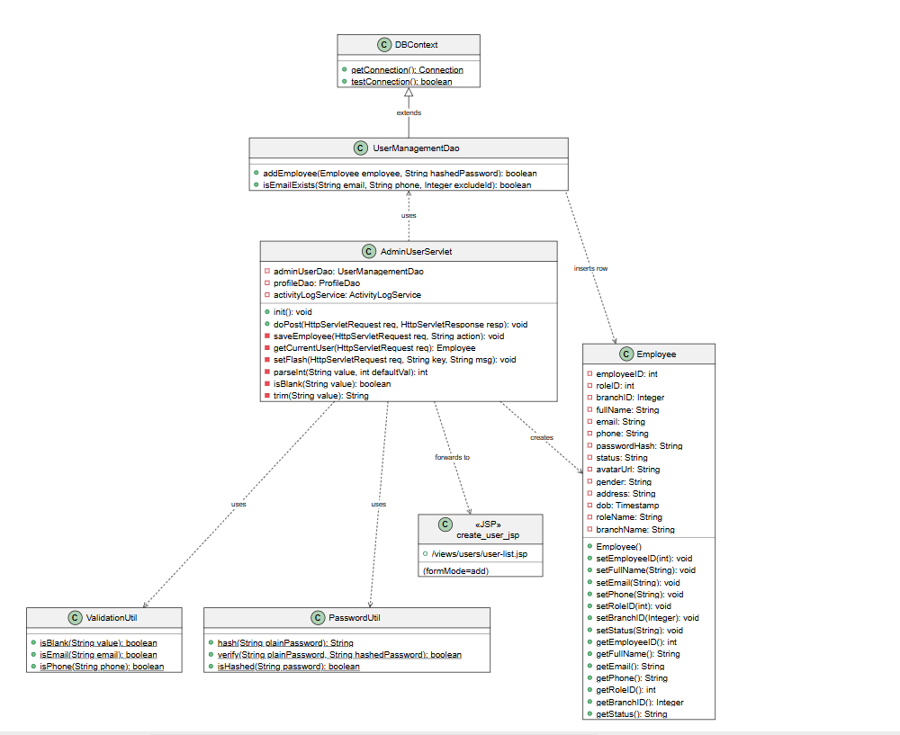

8. Edit User
- Class Diagram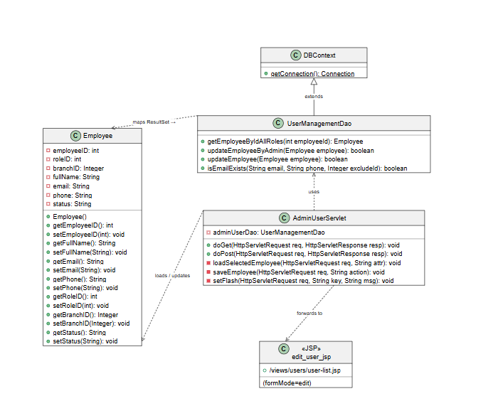

9. Search/Filter User
- Class Diagram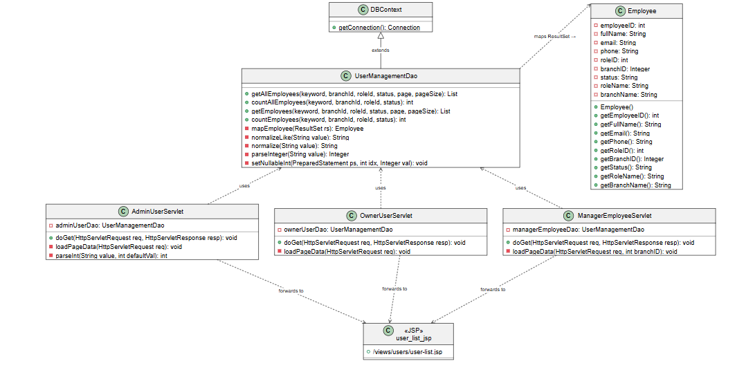

10. Employee Sales Report
- Class Diagram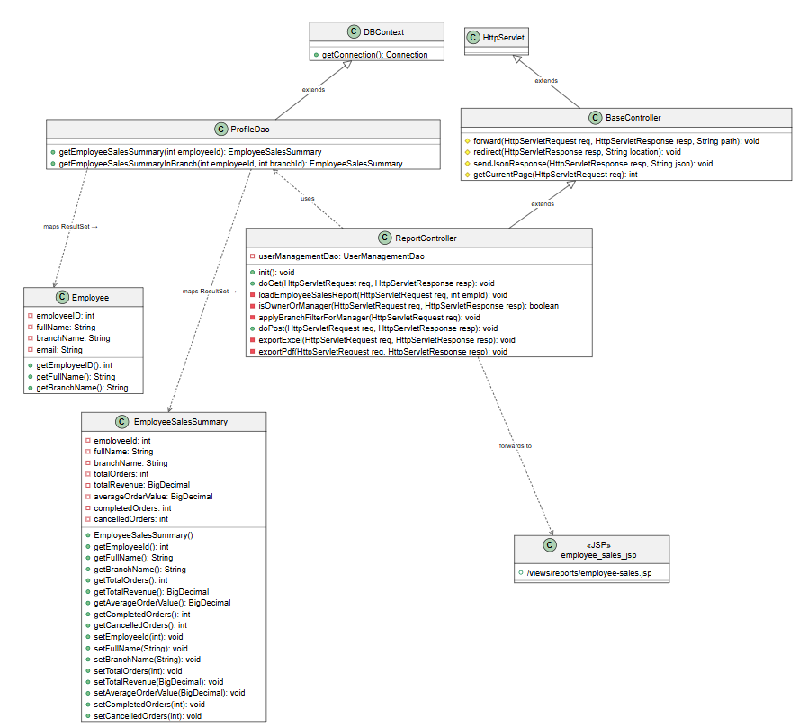

11. Change Password
- Class Diagram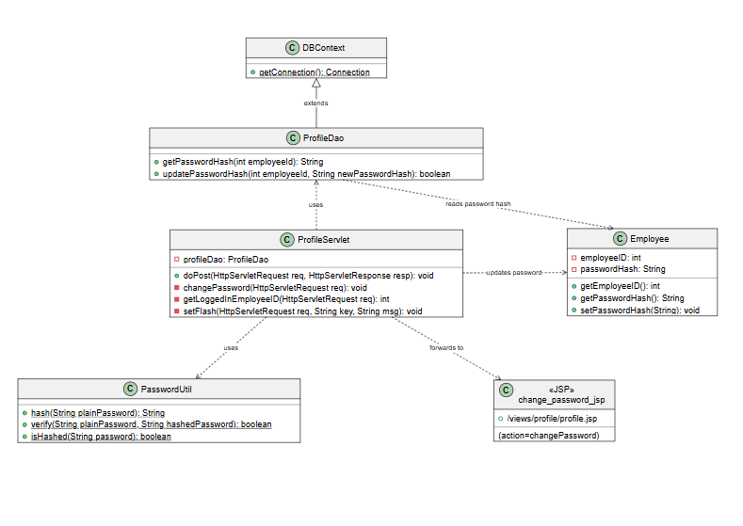

12. Redeem consumption points
- Class Diagram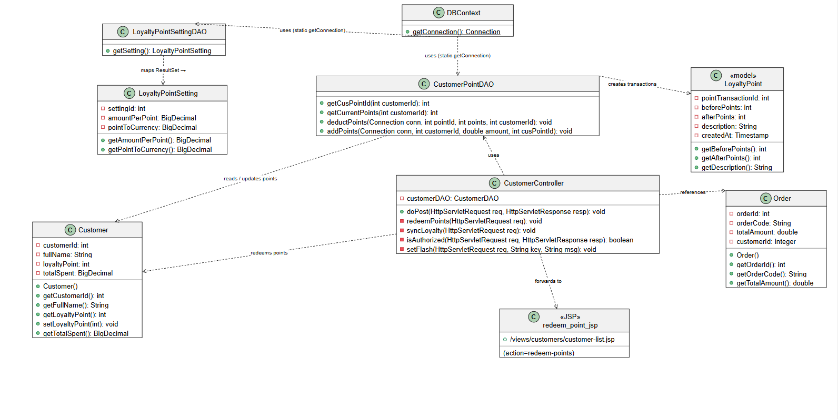

13. Lock / Unlock User
- Class Diagram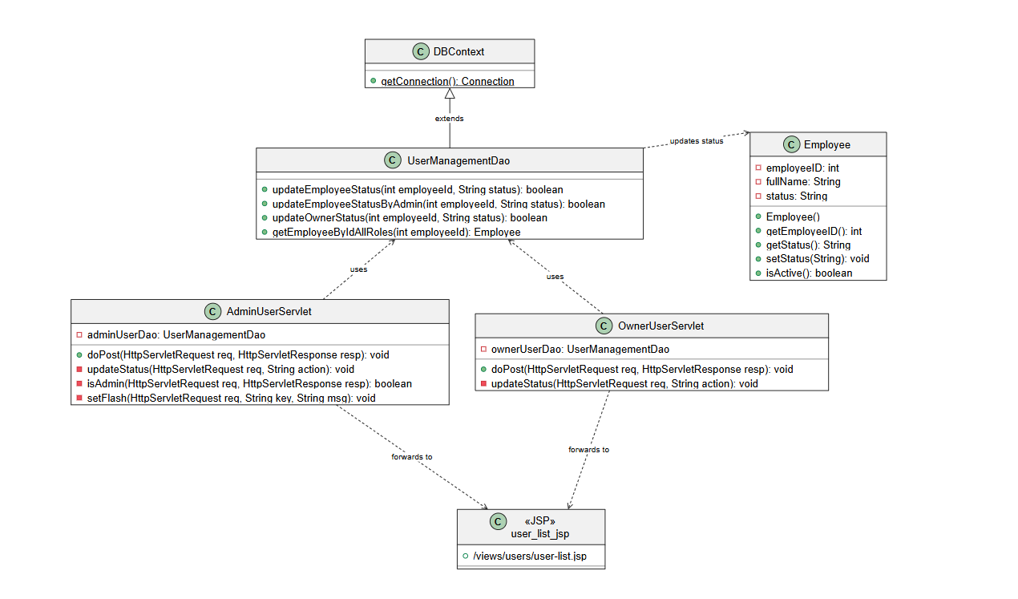

14. Edit Customer
- Class Diagram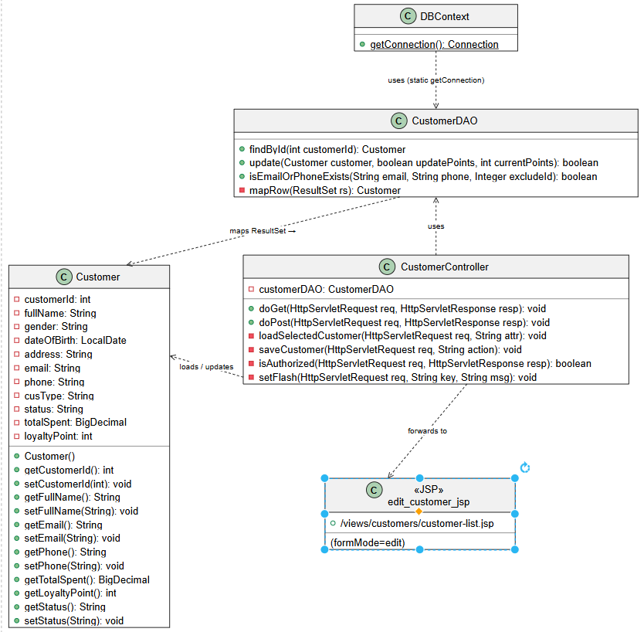

15. Add Customer
- Class Diagram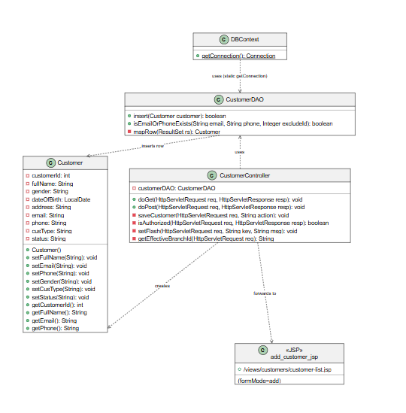

16. Customer List
- Class Diagram

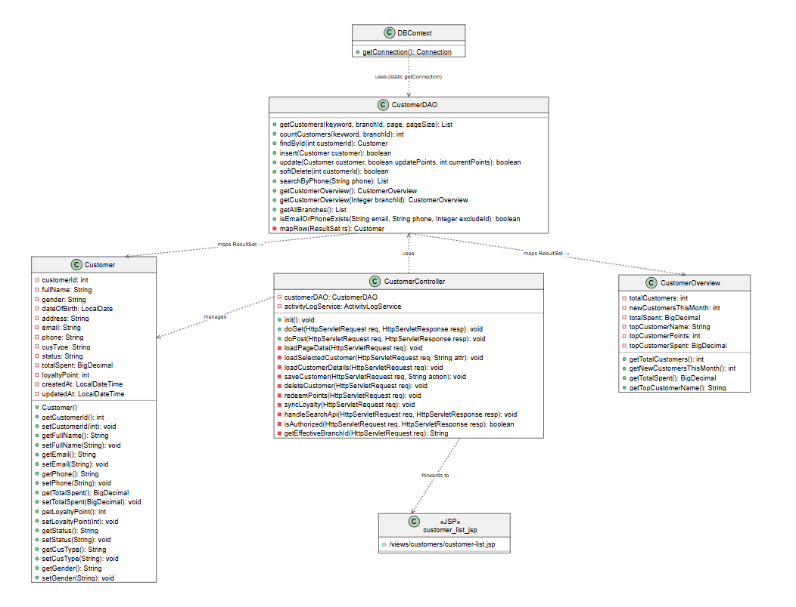

17. Search/Filter Customer
- Class Diagram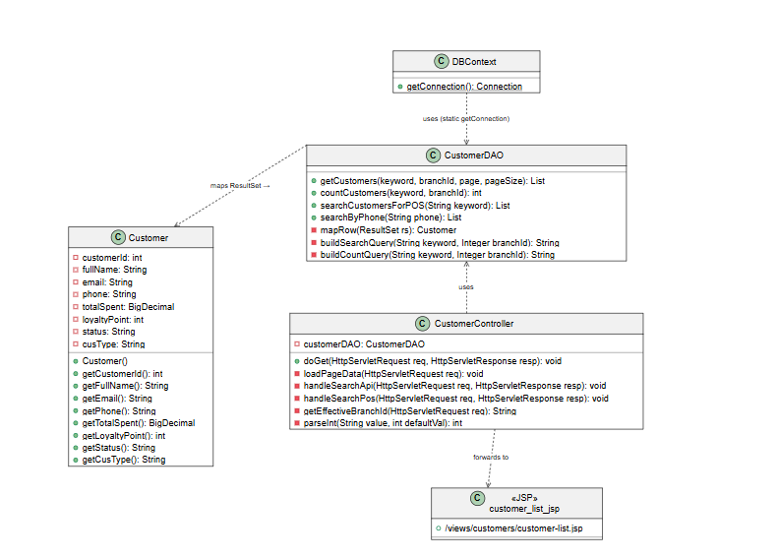

18. Customer Detail
- Class Diagram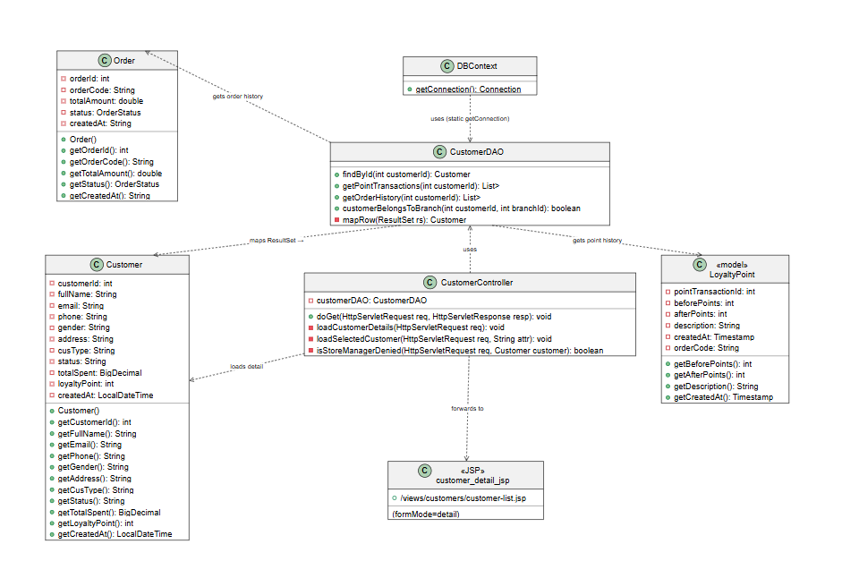

19. Profile
- Class Diagram
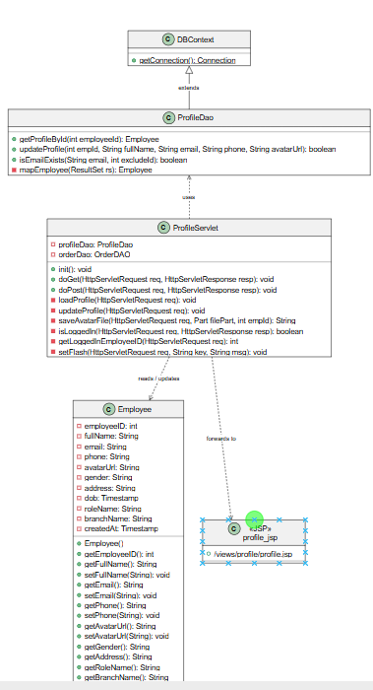

20. Branch manager
- Class Diagram
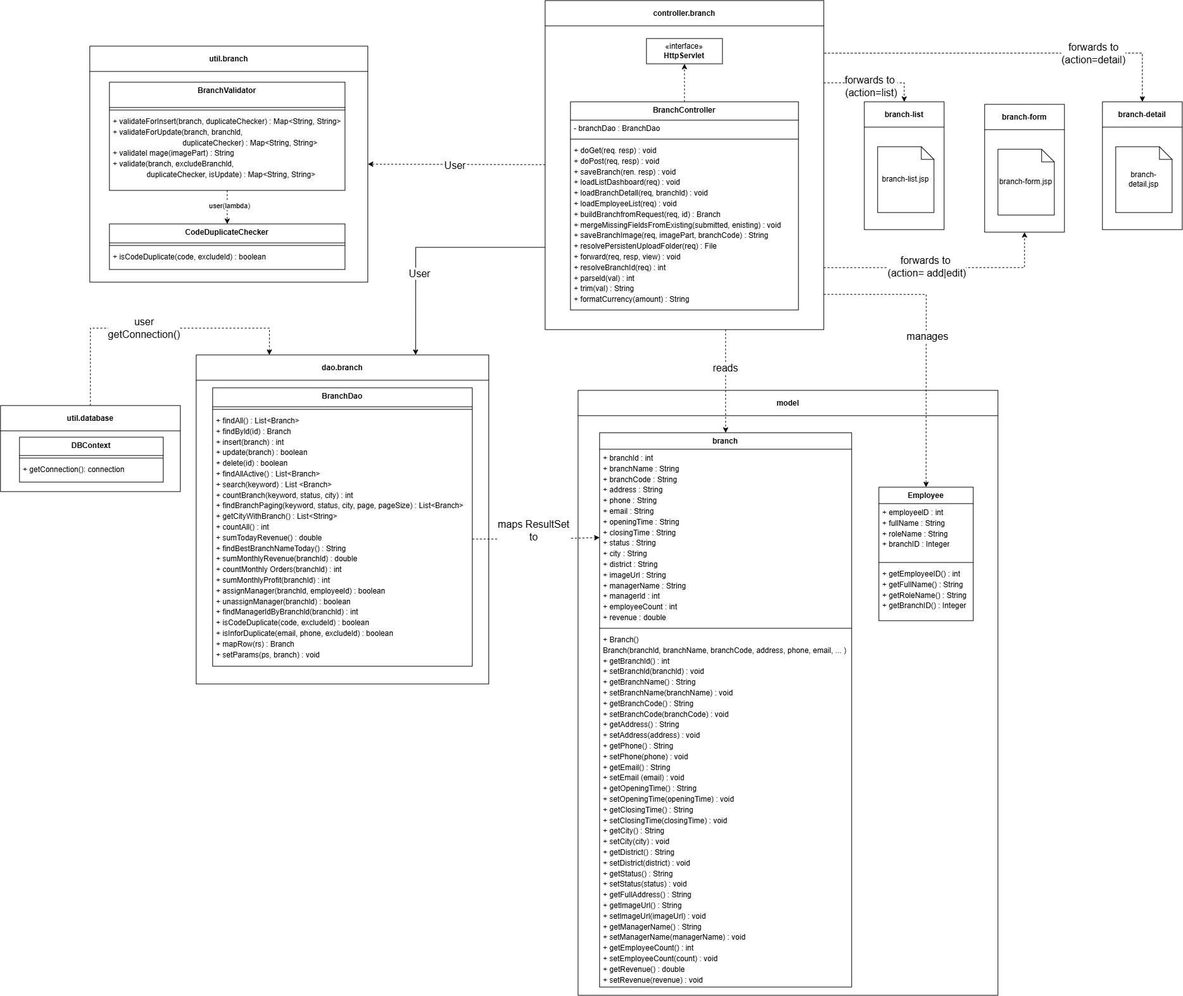

21. Branch manager

